**Name:Yinhui Wu**

**ID:300258115**

**business website: Don’t blink**

1. **Your previous experience in JavaScript development, and what you did as tutorial videos/readings to acquire the necessary skills to do the current project.**

In my previous experience with JavaScript development, I primarily relied on online resources such as tutorial videos and readings to acquire the necessary skills. Given my limited experience, I found platforms like W3Schools and YouTube to be valuable sources of information and learning. To start my project, I followed step-by-step tutorials on JavaScript fundamentals, including variables, data types, operators, functions, and control structures. W3Schools provided comprehensive documentation with practical examples that helped me grasp the basic concepts.

1. **Business Service type is chosen.**

Photography services

1. **Inspiration sites (sites you looked at to be inspired for your mockups and/or final UI).**

<https://www.mackeveland.com/>

1. **All your original mockups (what you submitted in Peergrade).**

See the PDF in the same folder

1. **In relation to your mockups, a summary of at least 2 UI elements you kept, and at least 2 UI elements you changed, following the received comments in Step 2 of this project.**

**2 UI elements you kept**:

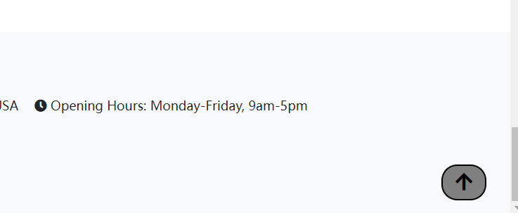

I keep the bring you back to top arrow, it make user much easier to go to the top and select element they want int the top

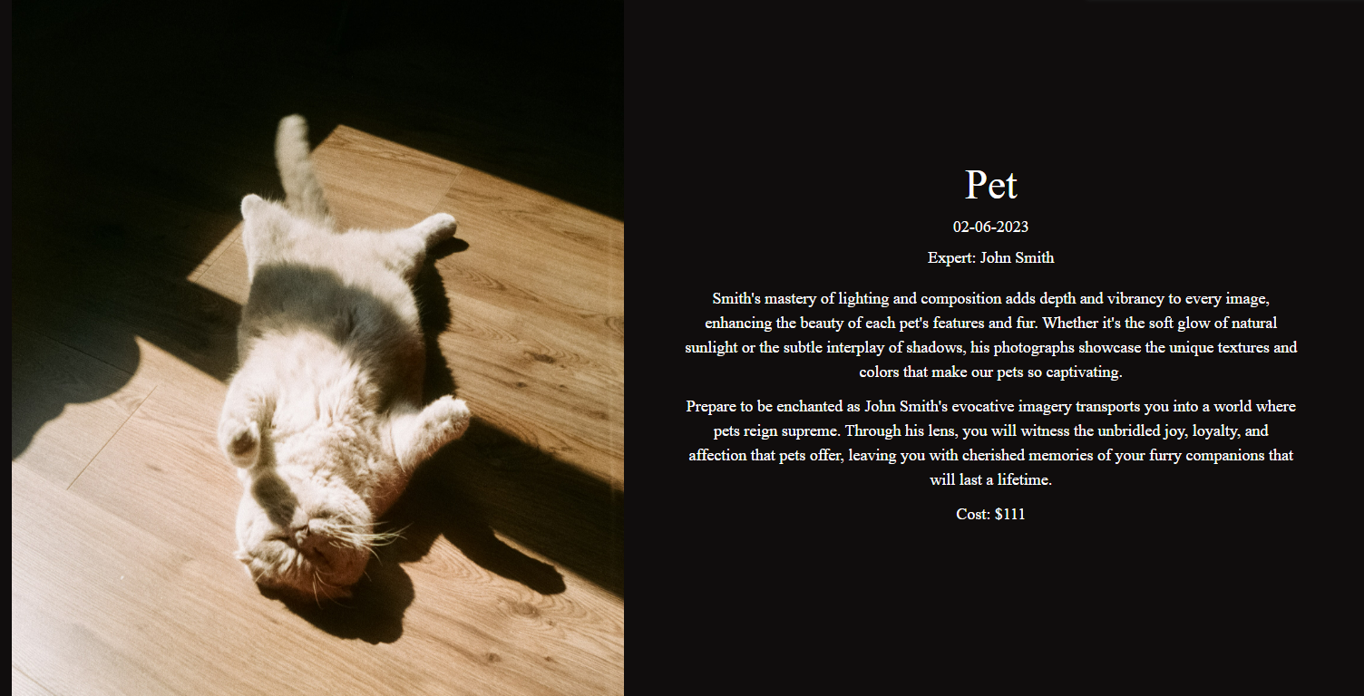

And i keep the photo gallery for service type design

**2 UI elements you changed:**

**Comment by Colleague:**

Currently, the booking and contact us pages are combined. To improve usability and streamline the user's journey, it would be more intuitive to separate these pages.

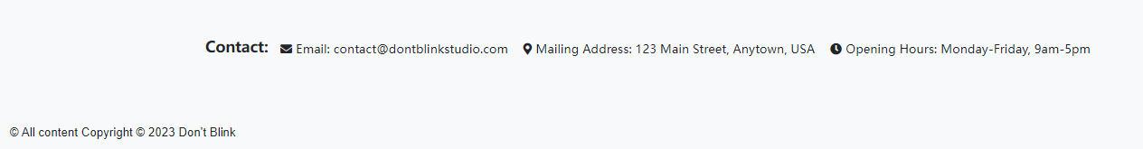

So i moved the contact information to the footer and the rest stay the same

**Comment by Colleague:**

On the home page I was not initially sure what the business type was (I thought it was something snowboarding or skiing related at first) so this could be made more clear, I'm also unsure what "some text here to" is supposed to be but that can be fixed easily for the final version. I don't see a clear way to navigate back to other pages from the confirmation page, consider adding a menu bar to the top of this page. I feel like the contact information should be on the about us page, not the booking page.

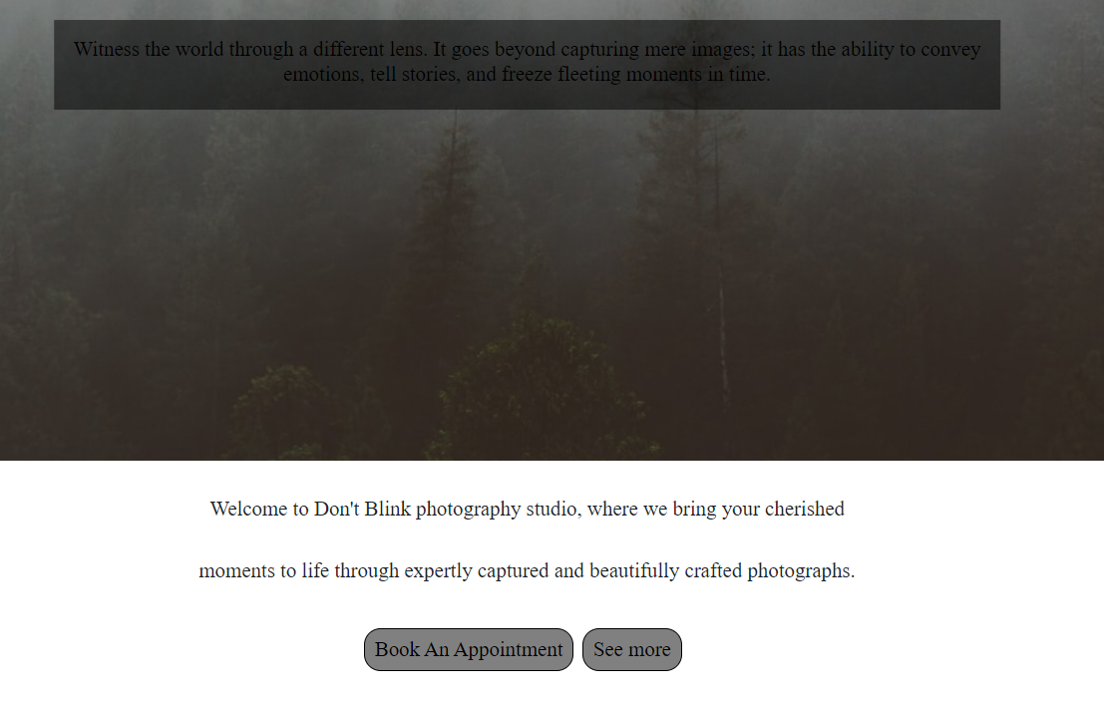

so i changed to this and make sure it pointed out what its this business type and have a two button to get them where they want, faster

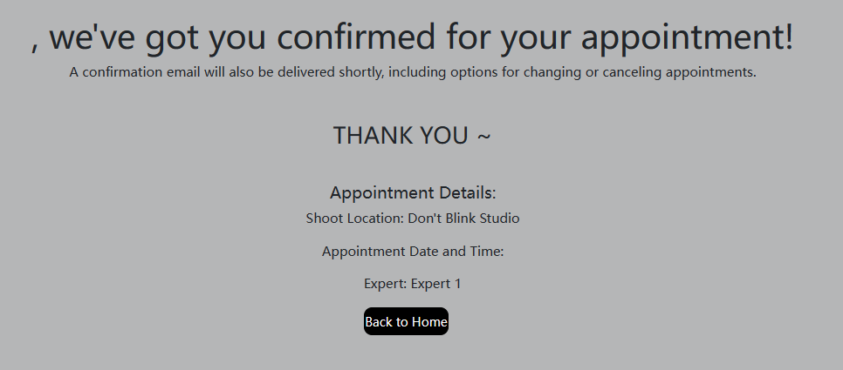and i added a “back to home button to bring the user back to the main page”

1. **A description of the two personas (with their goals) you chose to take into consideration in your UI, and why you chose those 2.**

1: Michael recently had a daughter, and he would like to have a photography session for her to capture memories. He doesn't feel like this falls into the other categories, so he doesn't know how to book this appointment.

Goal: Get a quote on a special category of photography (i.e., infants, wedding, etc.).

For this goal i added a message 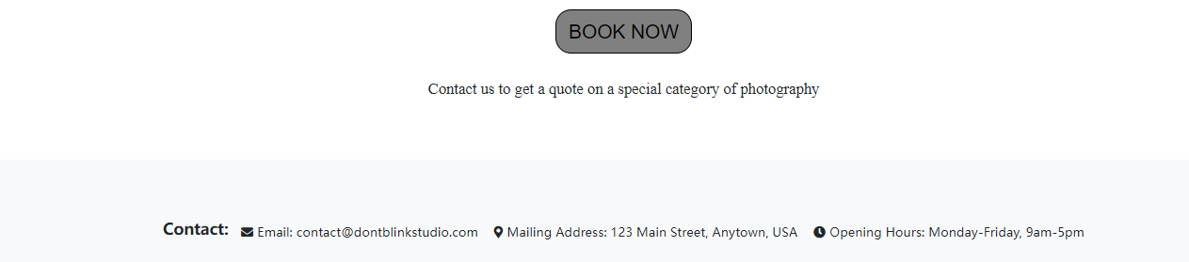

In the service page to make sure if user need to book a special type that did not list on the page

2:Goal: Would like to have professional photography done of their pet, cannot find a package for this on the site

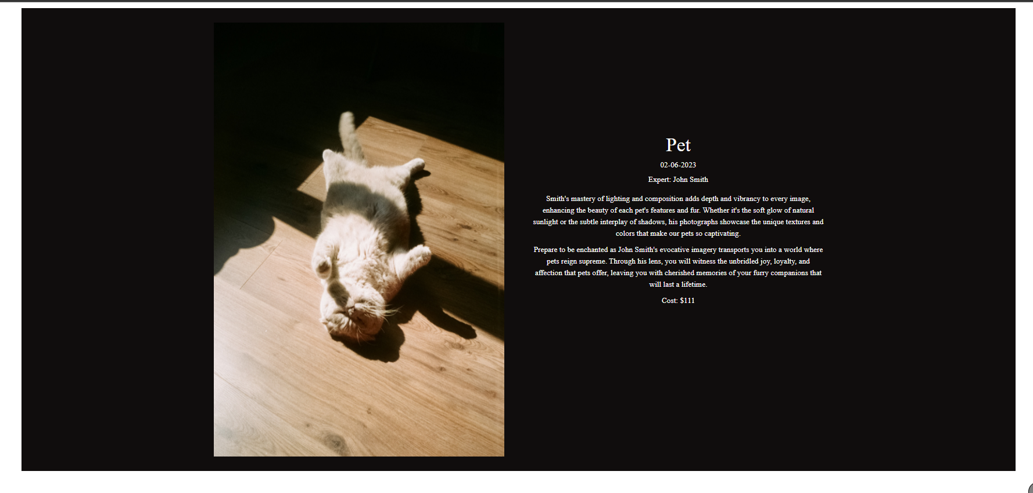

For this goal I directly added pet's service introduction and price

I chose these two because the other two remaining roughly aim to be close to these two, and it is indeed an important part that I think this site is missing

8. A link to your UI (on Github pages or another hosting site).

9. A link to your Bootstrap code (on GitHub or another accessible development site).

1. A presentation of 4 elements of your UI that relate to the concepts presented in class during week 3 on user goal-oriented interactions and week 4 on verbal and visual communication. For example, justify your choice of colors, typography, organization in your menus, etc.

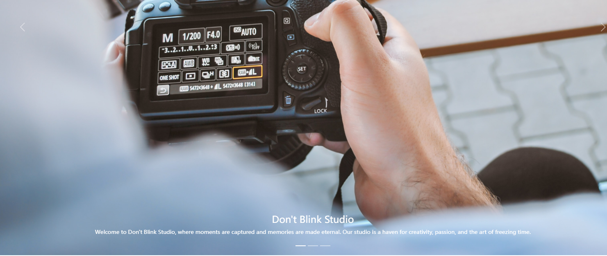

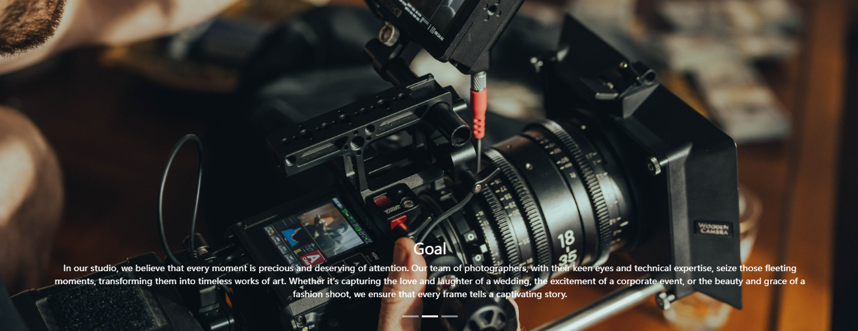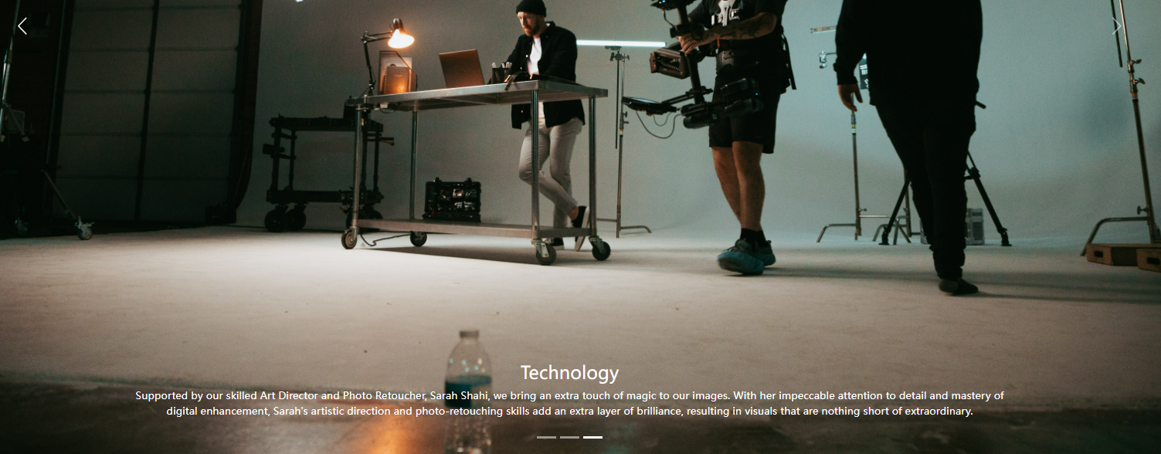

information organization

○ Grouping of similar information

○ Divide a large amount of information into several parts

○ Different formats for information presentation

A sliding photo browsing brings a different user experience and provides clear and orderly information.

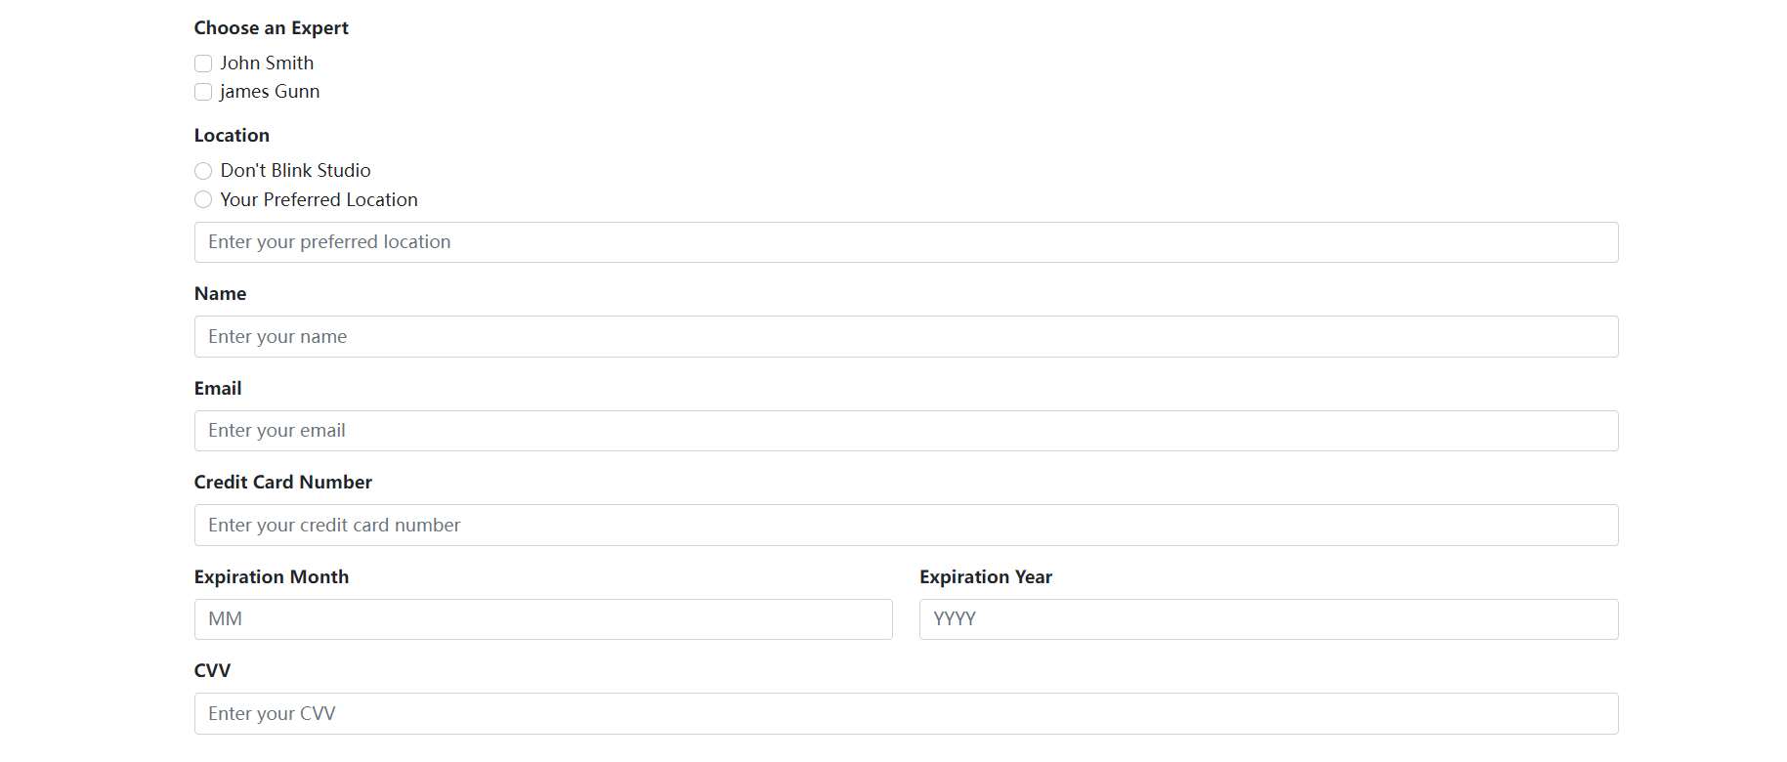

In order to facilitate user input, introductory text is added to each space, so that users can better understand what each line is and what needs to be done



○ Icons play an important role in "space-constrained" communication

○ Icon selection or design is not trivial

provide visual cues and enhance the overall design of my website. Icons help to quickly convey information and make it easier for visitors to scan and understand the content and touch of professionalism and modernity to contact details.

---------------------------------------------------------------------------------------------------------------------------------

**Color/Color Theme**

Clean and Minimalistic Design: A monochromatic color scheme can create a clean and minimalist aesthetic, giving the website a modern and sophisticated look. The use of white as the primary color helps create a sense of spaciousness and simplicity.

Timeless and Elegant: The combination of white, black, grey, and brown tones can evoke a sense of timelessness and elegance. These colors are often associated with sophistication, professionalism, and luxury. By using them as base colors, can create a visually appealing and refined design.

Visual Hierarchy and Readability: Monochromatic color schemes can help establish a clear visual hierarchy on the website. By using different shades of grey and brown, can differentiate between sections, headings, and content, making it easier for users to navigate and read the website.

Color Meaning Coherence: it's important to consider the meaning and symbolism associated with each color. For example, black can represent power and authority, while brown can evoke feelings of warmth and stability. By ensuring that the chosen colors align with my studio identity and the emotions I want to evoke, I created a coherent and meaningful color theme.

Versatility and Flexibility: A monochromatic color scheme provides a versatile foundation that can be easily complemented by accent colors or graphics when needed. It allows content, imagery, and other design elements to stand out and take center stage without clashing with a complex color palette.

This web provides great convenience, for example, it have “bring you back to the top” arrow, each page contains contact information and each page also has a Book button to take you directly to the booking form

Index: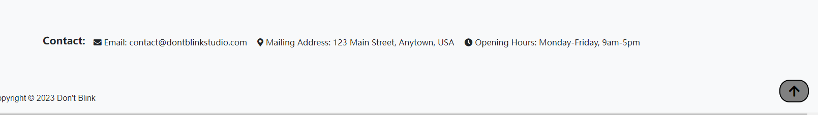



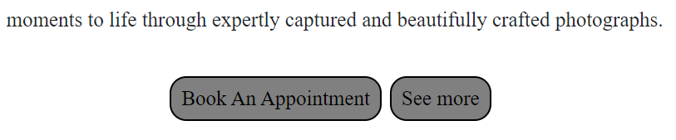

About page:

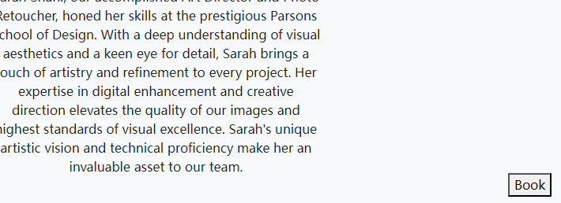

Fix book button

Services page:

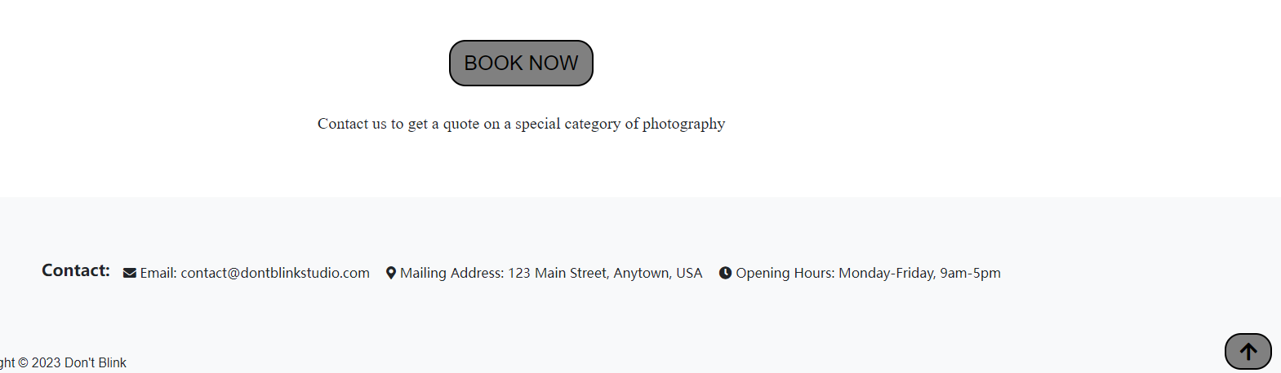

**4. Include an appendix on your contribution to your peers At the end of your report, add an appendix in which you copy the feedback + personas that you suggested to your peers. You can put one page per feedback. On each page, you must include:**

•

**Title of the website you reviewed:**

**hair salon business**

**•**

**Answer to the 4 questions asked**

Q1: Overall, your covers important aspects of a hair salon website, such as navigation, information about the salon and stylists, services and pricing details, and a user-friendly booking process. By incorporating these elements, you're creating a website that is informative, easy to navigate and caters to the needs of potential customers. and I love that you include the map on the "contacts us page"!

Q2: Confirmation (Page 6): In addition to displaying a booking number, consider providing users with a summary of their appointment details, including the date, time, and stylist they have booked. This will help users quickly confirm their reservation details without needing to refer back to previous pages. The navigation bar appears to be quite narrow, which could potentially impact its visibility and ease of use. Consider widening the navigation bar to provide more space for the menu items and enhance readability. A wider navigation bar allows for Larger text or icons, making it easier for users to quickly locate and select the desired options. Additionally, a wider navigation bar can accommodate longer menu item names without truncating them, ensuring that the labels are fully displayed and easily understandable. B y expanding the navigation bar's width, you can create a more visually inviting and user-friendly browsing experience for your website visitors.

Q3: a. Find out the business name and type:

The business name and type are clearly displayed on the landing page of the website. This allows the user to quickly identify the salon and understand the nature of the business.

b. Find out the address, phone number, and opening hours:

The contact information, including the address, phone number, and opening hours, it's easily accessible, preferably in the contact page section of the website. Providing this information prominently ensures that users can quickly find the necessary details to visit or contact the salon .

c. Find out the list of services provided, their description, and costs:

The services page presents a comprehensive list of the services offered by the salon. Each service is accompanied by a clear description and the associated costs. This allows users to browse through the different services, understand what they entail, and make informed decisions based on their preferences and budget.

d. Find out the list of service experts and what they do:

The experts/stylists page showcases the list of service experts along with their respective specialties and descriptions. This allows users to explore the expertise of each stylist and understand their areas of specialization, helping them choose the right stylist for their needs.

e. Book an appointment through a selection of a service, an expert, and a date and time:

The booking page provides a user-friendly interface where users can select their desired service, choose a preferred expert/stylist, and pick a suitable date and time for their appointment. The design is intuitive, allowing users to navigate through the options and make their selections easily.

f. Enter their name and email to be able to book an appointment:

The booking process includes a form where users can enter their name and email address to finalize their appointment. This information is crucial for communication and confirmation purposes. They are straightforward and clearly labeled, ensuring users can provide their details without confusion.

g. View a confirmation once the booking is done:

After completing the booking process, users will receive a confirmation page or notification that should display the details of their appointment, including the date, time, selected service, and stylist.

Overall, the design prioritizes clarity, ease of use, and intuitive navigation to enable users to perform the desired tasks seamlessly. It provides clear signposts and visual cues to guide users through the various sections of the website and facilitate a smooth booking process

Q4:

Persona:

Name: Emily Miller

Intrinsic Characteristics:

Busy Professional: Emily is a successful marketing manager with a hectic schedule. She values efficiency and convenience in her daily activities.

Tech-Savvy: Emily is comfortable using technology and frequently relies on her smartphone and online resources to manage her tasks and appointments.

Detail-Oriented: Emily pays attention to details and appreciates thorough information when making decisions.

Relation to Technology and the Domain:

Emily has a strong affinity for technology and utilizes digital platforms for various aspects of her life. She prefers online solutions that offer convenience and streamline her tasks. In the domain of a service-based website, Emily expects to find relevant information, book appointments easily , and have access to personalized features tailored to her needs.

Goal:

Emily's goal is to find a service expert who specializes in a specific hair treatment she requires. She wants to view detailed information about the expertise of the service experts, including their qualifications, experience, and customer reviews. However, the current website design lacks comprehensive information about the service experts, making it challenging for Emily to select the most suitable expert for her specific needs.

Suggested goal for the future version of the design:

The designer should focus on providing detailed profiles for each service expert, showcase their qualifications, areas of expertise, and customer feedback. Implementing this feature would enable Emily to make an informed decision when selecting a service expert, enhancing her overall exp experience on the website and increasing the likelihood of her booking an appointment.

**Title of the website you reviewed 2:**

**nail,wax and lash services•**

**Answer to the 4 questions asked**

Q1: The navigation bar at the top of the page is clean and easy to read. The font size and choice of color make it simple for users to identify different sections of the website. The use of whitespace throughout the design helps keep the layout uncluttered and easy to follow. This not only makes the site more visually appealing but also improves the user experience.

Q2: The booking process could be more intuitive. Instead of a dropdown menu, consider using a visual calendar to select a date and time, and a more interactive interface for selecting the desired service and expert. In the navigation bar, try to tell the user which page we are on.

Q3: a. Find out the business name and type:

On the homepage of the website, it has mentioned that the salon information, features, and services are introduced. This allows the user to quickly identify the business name and type when they land on the website.

b. Find out the address, phone number, and opening hours:

The homepage or the "HOME" page can include the salon's address, phone number, and opening hours, providing users with easy access to this essential information. This way, users can quickly locate and contact the salon.

c. Find out the list of services provided, their description, and costs:

By clicking on the "SERVICES" tab in the navigation bar, users can access a page that lists all the services provided. Each service can have a description and its corresponding cost, allowing users to browse through and get detailed information about the services offered.

d. Find out the list of service experts and what they do:

The "OUR TECHNICIAN" page lists all available technicians, enabling users to see the expertise of each technician and the services they provide. This allows users to make an informed decision when choosing a specific service expert.

e. Book an appointment through a selection of service, expert, date, and time:

When users are ready to make a reservation, they can click on the "Book Now" button. This action takes them to the booking page, where they can select the desired service, preferred technician, and suitable date and time for the appointment.

f. Enter their name and email to book an appointment:

During the booking process, the design prompts the user to enter their name and email, ensuring they provide the necessary information to complete the appointment booking.

g. View a confirmation once the booking is done:

After confirming their information, the design provides the user with final information about the booking, which includes the details of the service, technician, date, and time. This confirmation page assures the user that their appointment has been successfully booked.

Q4: Persona Name: Emma Davis

Intrinsic Characteristics:

Socially conscious: Emma prioritizes supporting businesses that align with her values, such as those using eco-friendly and cruelty-free products.

Budget-conscious: Emma is mindful of her spending and looks for affordable options without compromising on quality.

Perfectionist: Emma has high standards and pays attention to detail, seeking services that provide precise and flawless results.

Relation to Technology: Emma is comfortable using technology and relies on it to research and discover new beauty trends, read reviews, and compare prices. She prefers websites that are user-friendly and provide clear information.

Relation to the Domain: Emma enjoys pampering herself and frequently seeks nail, wax, and lash services to enhance her appearance. She values professionalism, cleanliness, and a comfortable ambiance in the salon.

Unmet Goal: Emma's want to have a loyalty program or rewards system integrated into the website. Emma wants to be rewarded for her loyalty and frequent visits to the salon. She envisions earning points or discounts for each service she avails or referring friends to the salon By having a loyalty program in place, Emma would feel appreciated and motivated to continue choosing the salon for her nail, wax, and lash services. This feature would enhance her overall experience and strengthen her connection with the salon.

**Title of the website you reviewed 3:**

**computer repair service type of business•**

**Answer to the 4 questions asked**

Q1: Fixed Navbar: Having a fixed navigation bar at the top of the website is a great choice. It ensures that important navigation options are always accessible to users, regardless of their position on the page.

Eye-catching CTA: Placing an eye-catching call-to-action (CTA) prominently on the page is a smart move. It helps to draw the user's attention and encourages them to take action, such as booking an appointment or getting in contact with the company.

Services and Team Sections: Including dedicated sections for services offered and team members with their specialties is a valuable addition. This allows users to quickly understand the range of services provided and the expertise of the team members.

Q2: Confirmation Page Details: While it's helpful to inform users about checking their email for further instructions, consider providing a brief summary on the confirmation page itself. This way, users can quickly review their appointment details without solely relying on email. so, consider adding a visual indicator or progress bar to show users how far they are in the booking process.

Footer Links: While having a footer with common links is a good practice, make sure the links are organized and labeled in a clear and intuitive manner. Consider categorizing the links (e.g., Services, About Us, Contact) and using appropriate icons or visual indicators to enhance usability.

You can provide multiple languages to better target more users.

Q3: a. Find out the business name and type:

The business name and type are likely displayed prominently on the homepage, as mentioned being inspired by Canada Computers. This allows the user to quickly identify the business and its focus.

b. Find out the address, phone number, and opening hours:

The "Hours & Location" section provides the store's address, phone number, and opening hours. This information is easily accessible, allowing the user to find the necessary contact details and operating hours of the business.

c. Find out the list of services provided, their description, and costs:

The design includes a section dedicated to displaying the list of services offered. Each service likely includes a description and cost associated with it. This allows the user to browse through the services and gather information about what is offered and at what price.

d. Find out the list of service experts and what they do:

design incorporates a section showcasecasing the team members and their specialties, the user can easily access the list of service experts and learn about their areas of expertise. This allows the user to make informed decisions when booking an appointment.

e. Book an appointment through the selection of a service, an expert, and a date and time:

By providing an appointment booking feature, the design allows users to select their desired service, choose a service expert, and pick a suitable date and time for their appointment. This functionality enables users to conveniently schedule their appointments based on their preferences.

f. Enter their name and email to be able to book an appointment:

To book an appointment, users are likely required to enter their name and email address. This allows the business to collect the necessary contact information and ensures that users can receive confirmation and further communication regarding their appointment.

g. View a confirmation once the booking is done:

After submitting the appointment request, the design directs the user to a confirmation page, which provides reassurance that their request has been received. Additionally, users are informed to check their email for further instructions. This confirmation page allows users to have visibility and conf idence in their appointment booking.

Q4:Name: Juan Ramirez

Three Intrinsic Characteristics:

Multilingual: Juan is fluent in English, Spanish, and French. He prefers to interact and receive information in his native language, Spanish, to ensure clear understanding and effective communication.

Limited English Proficiency: Although Juan has some understanding of English, his proficiency is not high. He feels more comfortable expressing himself and understanding complex concepts in Spanish.

Technologically Challenged: Juan has limited experience with technology and finds it challenging to navigate websites and digital platforms. He prefers straightforward and intuitive interfaces that require minimal technical knowledge.

Relation to Technology and Domain:

Juan recognizes the importance of technology but feels somewhat overwhelmed by it. He primarily uses technology for basic tasks like communication and information gathering. In terms of the computer repair domain, Juan relies heavily on experts to resolve technical issues and seeks accessible resources that can help he understands the process in his native language.

Goal not met by the actual functionalities offered:

Juan's goal is to have the website available in Spanish, with all the content, including service descriptions, pricing, and booking forms, translated accurately. While the current design may be in English, offering a language toggle or a separate Spanish version of the website would allow Juan to access the information he needs comfortably. By accommodating different language preferences, the design can cater to a wider audience and create a more inclusive and user-friendly experience for individuals like Juan.

**Title of the website you reviewed 3:**

**dental clinic•**

**Answer to the 4 questions asked**

Q1: I like the color design of your website, it makes users feel comfortable and clear. Specialist Information: The Teams section is a valuable addition to the website. It provides users with information about the specialists at the dental clinic, including their areas of expertise and contact details. This feature enhances transparency and builds trust by allowing users to learn more about the professionals they may potentially visit.

Q2: Confirmation page design:

Appointment Details: Clearly display the appointment date, time, and specialist's name in a prominent and easy-to-read format. Utilize a larger font size or bold styling to make these details stand out. Ensure that the information is placed prominently at the top or center of the confirmation page.

Visual Cues: Incorporate visual cues such as checkmarks, icons, or graphics to signify successful booking and confirmation. These visual elements can help reinforce the message that the appointment has been successfully scheduled.

Q3: The homepage serves as the main entry point, providing an overview of the dental clinic's services and guiding users towards relevant sections. The navigation menu is prominently displayed, allowing users to explore different areas of interest.

When users want to find out the business name and type, they can quickly identify this information through clear branding elements such as the logo and tagline, which are typically visible on the homepage or website header.

To discover the address, phone number, and opening hours, users can easily locate the "Contact Us" page through the navigation menu or footer. These sections present the necessary contact details, ensuring users can readily access the information they need.

The design effectively showcases the list of services provided, their descriptions, and costs in an organized manner. Users can navigate to the "Services" section, where services are presented in a clear and concise format. Each service description is accompanied by relevant information, allowing users to make informed decisions.

In the "Teams" or "Specialists" section, users can explore the expertise of the service experts. The design presents the specialists' details in a visually appealing and informative manner, helping users understand their qualifications and specialties.

The booking process is straightforward and intuitive. Users can access the "Book" or "Appointment" section, where they are guided through selecting their desired service, expert, and preferred date and time. The design ensures that users can easily progress through the booking flow, making their selections and confirming their appointment details.

During the booking process, users are prompted to provide their name and email. The design incorporates a clear and user-friendly form that allows users to input their information seamlessly, without confusion or unnecessary steps.

Once the booking is completed, the design presents a confirmation page that provides users with the essential details of their appointment. This confirmation page ensures users that their booking has been successfully processed, without explicitly instructing them on what to do next.

Q4: Persona Name: Sarah Rodriguez

Intrinsic Characteristics:

Health-conscious: Sarah prioritizes her health and seeks services that promote well-being and hygiene.

Convenience-oriented: Sarah values efficiency and convenience in her daily life, seeking services that are easily accessible and save her time.

Value-conscious: Sarah prioritizes getting the best value for her money and seeks services that offer competitive pricing without compromising on quality.

Relation to Technology: Sarah is Comfortable USING Technology and Relies on It For Various Tasks. She Frequently Ueses Online Platforms to Research and Book Servi. CES, Including the Dental Clinic's Website. She Experts The Website to Be User-Friendly, Responsive, and Proven A Seamless experience.

Relation to the Domain: Sarah recognizes the importance of dental care and regularly seeks dental services to maintain her oral health. She values a dental clinic that offers a range of services, prioritizes cleanliness, and provides a comfortable and welcoming environment.

Unmet Goal: Sarah's goal is to have access to an online portal where she can securely view her dental records, including previous treatments, appointments, and recommendations. This would enable her to track her dental history, stay informed about her oral health, and conveniently access her records whenever needed. Having this functionality on the dental clinic's website would enhance Sarah's experience, provide transparency, and enable her to actively participate in her dental care.